SACAIR Hackathon – 4 December 2023

Getting Started

Table of Contents

1. Introduction 3

2. Generate Problem Statement 3

3. Design 3

4. Development / Modelling 3

5. Presentation 4

6. Assessment Criteria 4

7. Environment and Submissions 4

7.1 Starting resources 4

7.2 Environment 5

7.3 Submissions 6

8. Dataset Details 6

8.1 Eskom Data 6

8.2 Weather Data 6

# Introduction

A hackathon, also known as a codefest, is a social coding event that brings computer programmers and other interested people together to improve upon or build a new software program.

In this Hackathon, we will be reviewing data from Eskom, finding insights, designing a process flow and building a model to predict something interesting.

You will be assessed based on the novelty, creativity and usefulness of the problem you are try to solve, the model built, and how the insights are presented.

As this is only a day-long event, you will not be judged on the accuracy of the data model (they can take weeks/months to develop properly). You will be assessed on insightfulness shown, the creativity of the problem you’re trying to solve, the use of good data science practice and principles, making clever, logical assumptions, and presenting your findings in a clear, professional manner that tells the data story.

The following sections will guide you as to what is expected for this Hackathon.

# Generate Problem Statement

Explore the dataset. Decide on which problem you are trying to solve. What is a question that would be most useful to answer? Think about the business, engineering, social and/or environmental benefits in solving this problem. Be Creative!

Suggested problems could include:

* 1. How much diesel does Eskom use?
  2. When would be the optimal times to perform planned maintenance on the generation fleet?

Feel free to find additional datasets to answer the question you’re trying to solve.

# Design

Given the problem you are trying to solve, think about where that data might come from, and how it could be ingested into your platform, processed, stored and served. Think about and discuss how this could be implemented in practice.

Give a basic, high-level process flow from source data to front-end reporting.

# Development / Modelling

Identify the dependent and independent variables in what you are trying to represent and find correlations between them. Identify the most appropriate model to solve the problem and build it. What are the assumptions included in your modelling and/or decision-making?

Of course, you will not be able to build an end-to-end solution. Credit is awarded for good data science practice, making of good, logical assumptions, identifying and using the correct data to address the problem statement.

# Presentation

You will be required to present a 3-minute elevator pitch with slide deck. This should tell the data story. Talk us through the model, the assumptions and the solution. Credit is awarded for the content of the presentation and talk, not necessarily how pretty the slides look.

# Assessment Criteria

You will be assessed on the following criteria (from most to least important):

1. Completeness of vision.
2. Creativity – Is the problem you are trying to solve unique and insightful?
3. Good data science practice.
4. Presentation – data storytelling.
5. Accuracy of the model.
6. Collaboration.

# Environment and Submissions

## Starting resources

Navigate to: <https://github.com/jules-deponte-entelect/SACAIR-Hackathon-2023>

Select **<> Code** and download ZIP. This contains the data and starter code.

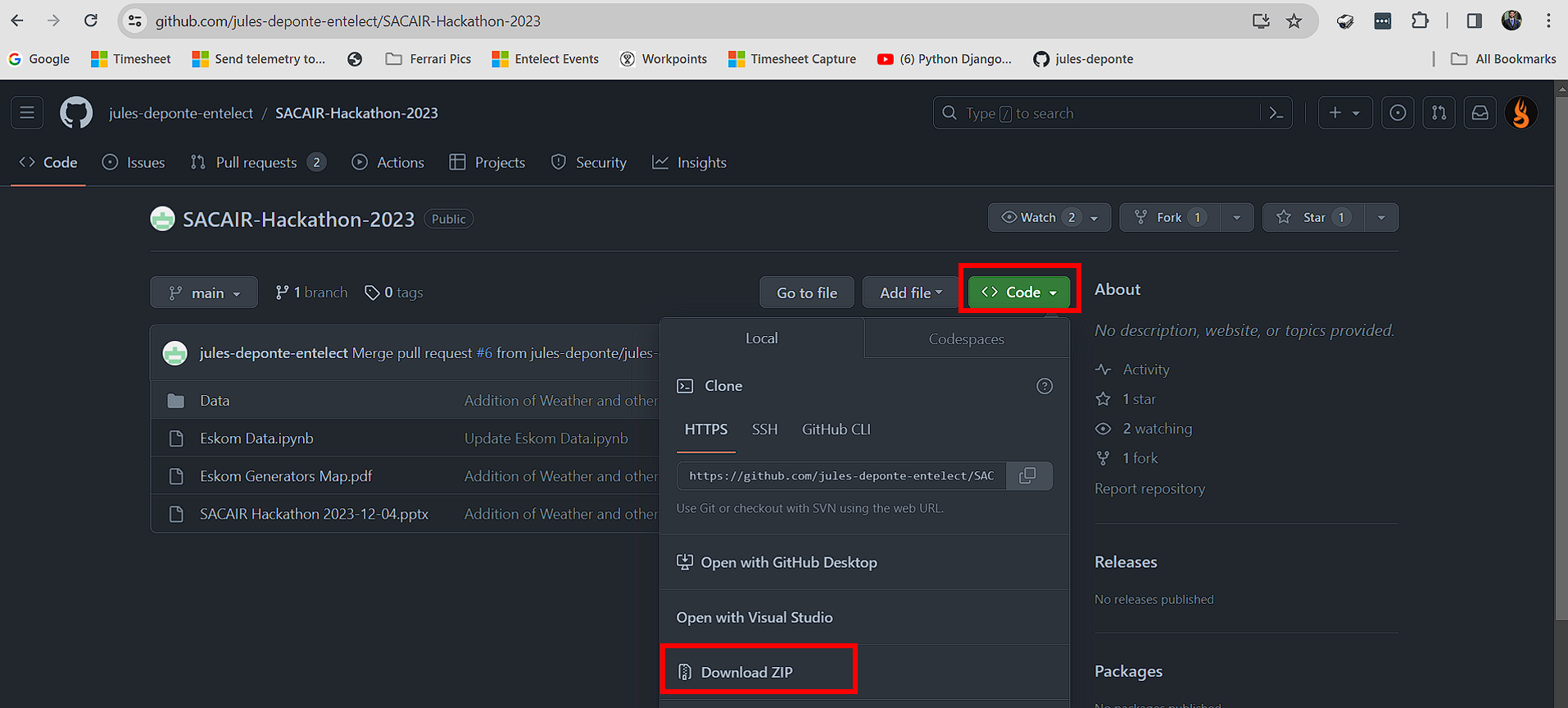

## Environment

This Python assumes that you will be working in Python and using Notebooks for coding. The suggested environment for this project is Google Colab.

Navigate to: <https://colab.google/> and sign in with your Google account, and select **New Notebook**

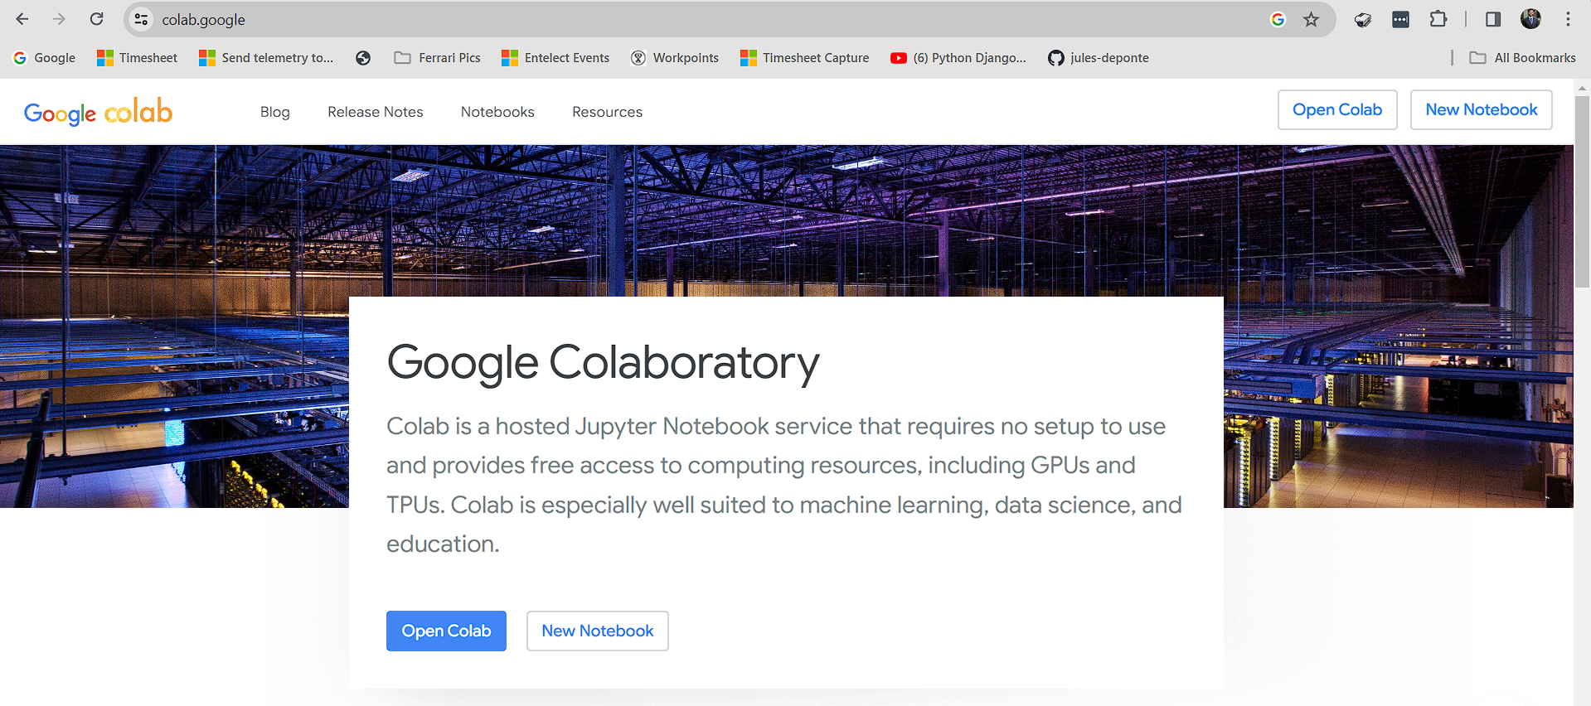

On the left, select the folder icon, right-click on the menu pane and select **Upload**. Upload the datasets and the starter code to the folder.

Start coding!

## Submissions

Once finished, placed all of your project artefacts into a single folder, ZIP it, and name it:

**SACAIR Hackathon - <Your Team Name>**

Place the ZIP file into the follow Google Drive folder:

<https://drive.google.com/drive/folders/1mcF_8_kHb6UYZC-pX1gVtiWM45QMXO5y?usp=sharing>

# Dataset Details

The following datasets are provided. Feel free to find additional data to support your project.

## Eskom Data

1. Data is supplied at an hourly granularity.
2. Data about Eskom power demand, energy generation and capacity (MW), averaged over an hour interval.
3. Energy generation by generation/supply type (international imports, coal, gas, open cycle gas turbine, hydro-electric)
4. Installed generating capacity.
5. The rated energy generation capacity by generation type.
6. The various types of outages that contribute to load shedding (these outages are described in the data dictionary)
7. Energy consumption by power plants used to generate power (referred to as Synchronous Condenser Operation. A technical understanding of this is not needed; a basic description is given in the data dictionary).
8. Tons of Carbon emissions per month. This is the lowest level of granularity of data available.

## Weather Data

1. Data is supplied at a daily granularity.
2. Data is supplied for the following locations:
   1. Johannesburg
   2. Pretoria
   3. Cape Town
   4. Durban
   5. Port Elizabeth
   6. Bloemfontein
   7. Upington
   8. Koekenaap
3. Temperatures, min, max, average (deg C)
4. “Feels like” temperature min, max, average.
5. Solar energy ()

Wind speed (km/h) and direction (deg) (North at 0 deg)